**Tutorial No. 1**

**Title: Planning a web site by creating layout for the webpages**

**Batch: B2 Roll No.: 1914078 Tutorial No.: 1**

**Aim: To understand concept of planning a website**

**___________________________________________________________________________**

**Resources needed: Internet ___________________________________________________________________________**

**Theory:**

**Following Steps can be followed for layout designing of a website.**

**Site Map**

Draft a sitemap that meets the description provided below.

Show the hierarchy and relationships between pages starting with the index page at the top. Create a digital copy of your sitemap using a word editor or visual editing programs like a mind mapping application or Visio. Be sure to save your document in a format that is widely supported and has a high enough resolution to be legible, like jpg, HTML, or pdf. Unless you are sure the parties who will receive these types of documents are using the same program you are, you should avoid proprietary file types.

**Site Wireframe**

Design two or three basic layouts for your site, or the alternative example described in the Site Map assignment, including a front page and typical content page for each. Include depictions of where certain pieces of content are expected to be located with their approximate size. Keep in mind a wireframe is about content elements and location, not a specific style, color, or actual content.

**Storyboarding**

Create a storyboard of a possible user experience your site. You might follow the process of signing in, creating an account, searching for a product, or navigating to a particular piece of content. Find an example that involves at least 4 steps. Create a mockup for each step that includes color and fake content, describing on each panel what action the user will follow to move to the next step.

**_______________________________________________________________________**

**Activity:**

1. Choose topic for website

2. Describe content of website in detail

3. Prepare layout of web site

**_______________________________________________________________________**

**Topic of Web site:** Portfolio Site

**_______________________________________________________________________**

**Content of Web site:**

* Greetings and About Me
* My passion
* Portfolio of work
* Services/Skills
* Contact Me

**________________________________________________________________________**

**Layout of Web site:**

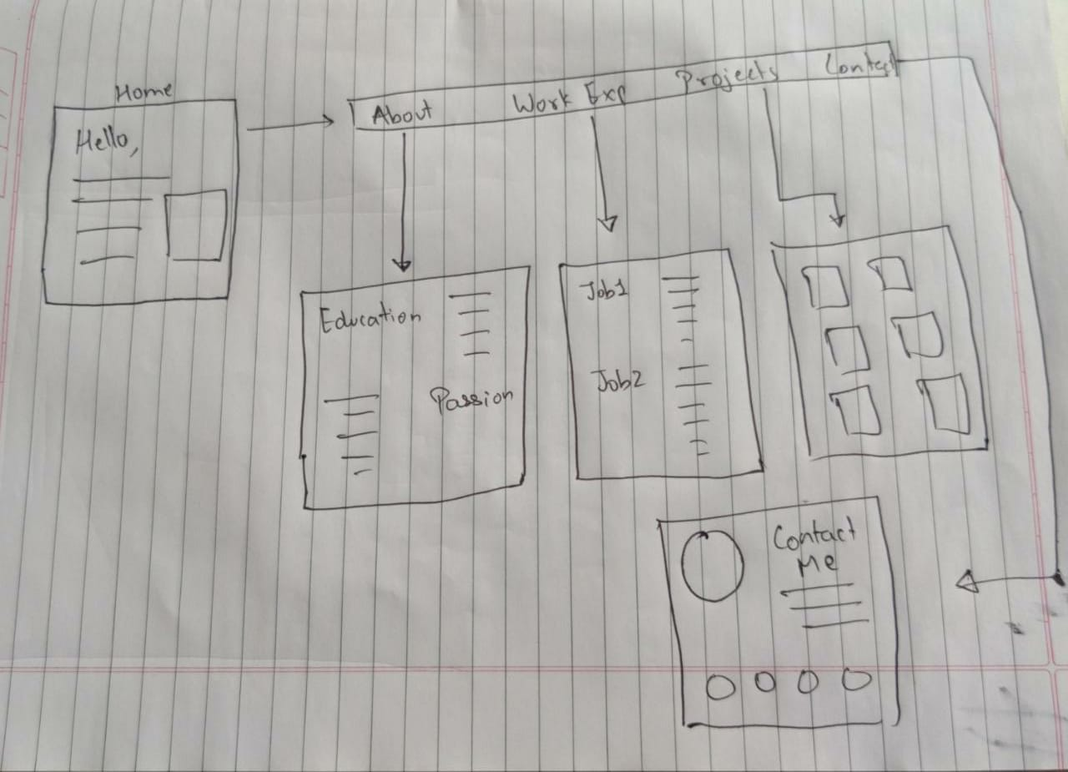

**___________________________________________________________________________**

**Outcome:** Comprehend basics of Web Technology

**___________________________________________________________________________**

**Conclusion:** We understood concept of planning a website

**References:**

1. <https://eng.libretexts.org/Bookshelves/Computer_Science/Book%3A_Web_Development_and_Programming_(Mendez)/01%3A_Web_Development/1.E%3A_Web_Development_(Exercises)>
2. More references to be added by student as required.